
∑.E.M.
Releases notes v1.06

Releases notes
v1.06
Bugs & Change 3
Improvement 4
Service load rate #175 4
Online Status & Last Seen #190 4
Export invoices lines #158 5
STL viewer #200 5
Add filters to sort tasks #209 6
Ability to create a product/item from an order line #165 6
Add to quote & order list, statu filter #218 7
Improve task view list #219 7
Not include generic task in date calculation #220 7
Change logo #231 8
Csv import #226 8

Bugs & Change

#191 - Name of Delivery note title on Invoince Page
#192 - Number of increment for invoice not increase
#189 - Add alerte, If user had no role
#188 - Controllers/Admin/Announcement.php does not comply with psr-4 autoloading standard
#194 - Column too much in delevery request
#193 - Wrong date invoiced on chart
#196 - Change Created at by difference from now
#197 Dashbaord value is wrong
#208 - Bump browserify-sign from 4.2.1 to 4.2.2
#205 Bump postcss from 8.4.12 to 8.4.31
#206 Bump @babel/traverse from 7.17.3 to 7.23.2
#207 Bump crypto-js from 4.1.1 to 4.2.0
#202 - 500 Oops! Internal Server Error. on delevery page
#210 - Error 500 if you click on all notifications, but there are no notifications
#217 - Order list page get 500 error after update info
#212 - Maintenance page
#211 - Upgrading Laravel To 10.0 From 9.x
#213 - Update livewire to v3
#214 - Check if delevey line selected was correct
#222 - Add success bg to header modal for new record modal
#221 - Define manualy end date for task
#223 - Update task activitys when task change on kanban board
#232 - Product image upload not working
#234 - Bump axios from 0.21.4 to 1.6.0
#215 - Calendar not working after laravel and livewire update
#233 - images upload not working
#237 - 500 error after set the Estimated Budget
#240 - Attempt to read property "id" on null
#239 - Add budget, not refrech
#245 - Internal order can be add on an empty stock list
#241 - Create item from this line, return error if no service created
#243 - production.ERROR: Undefined variable $__empty_2
#244 - Error when internal stock is put in location stock
#246 - Error if qty mini is null

Improvement

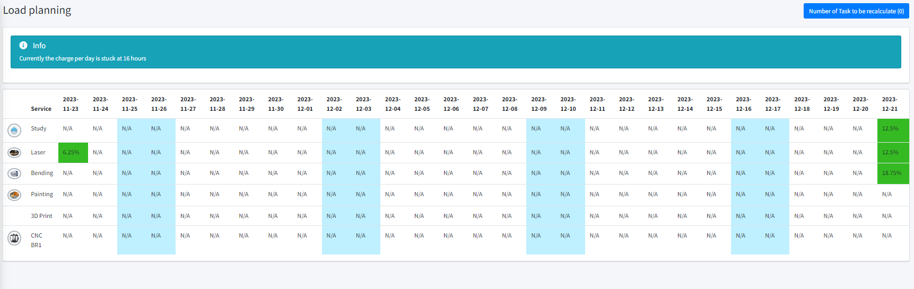
Service load rate #175

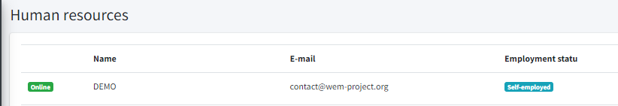
Online Status & Last Seen #190

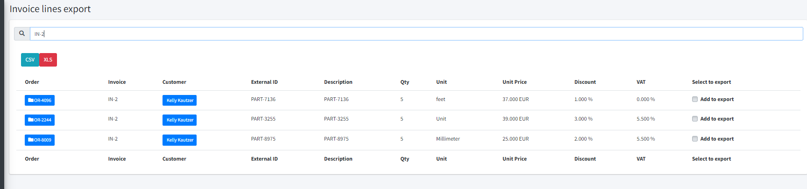
Export invoices lines #158

STL viewer #200

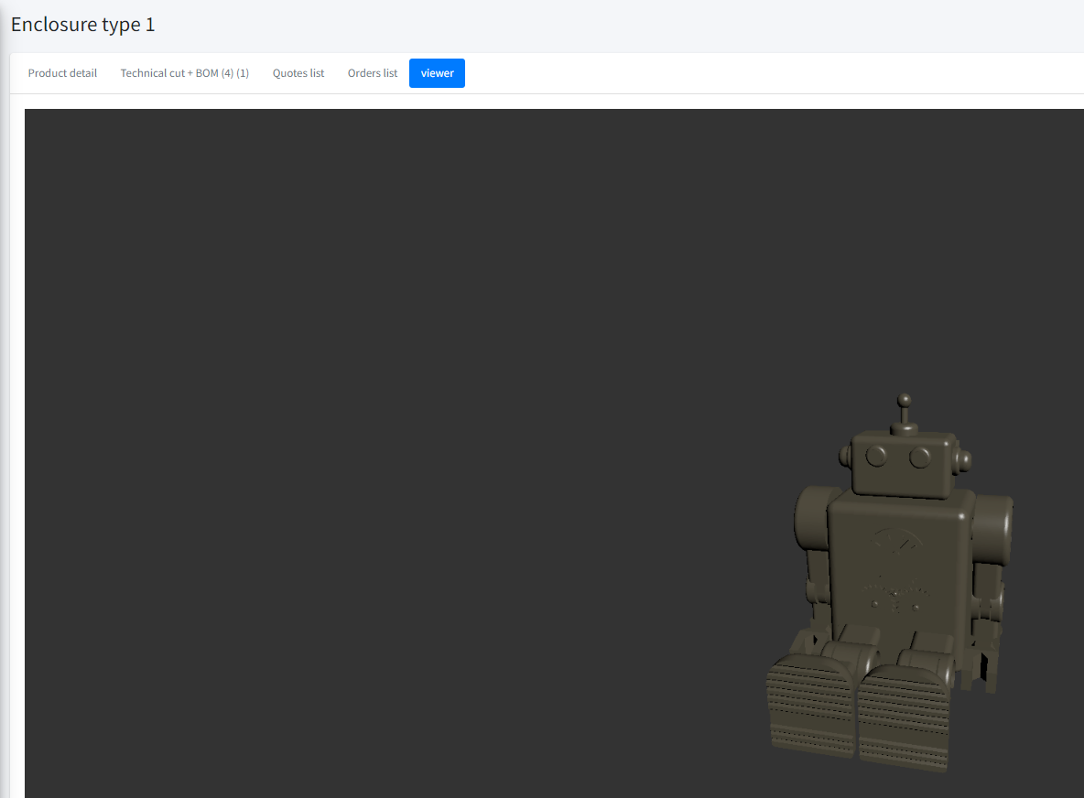

Add filters to sort tasks #209
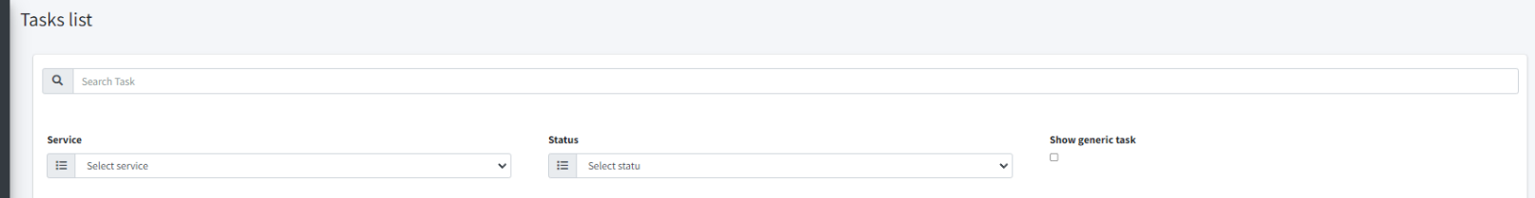

Ability to create a product/item from an order line #165
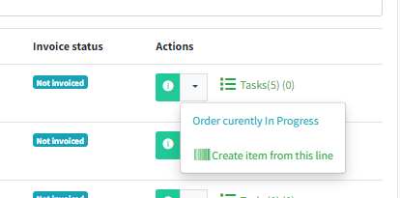

Add to quote & order list, statu filter #218
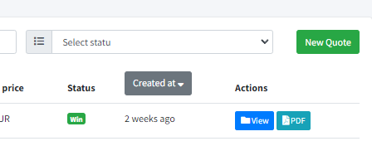

Improve task view list #219
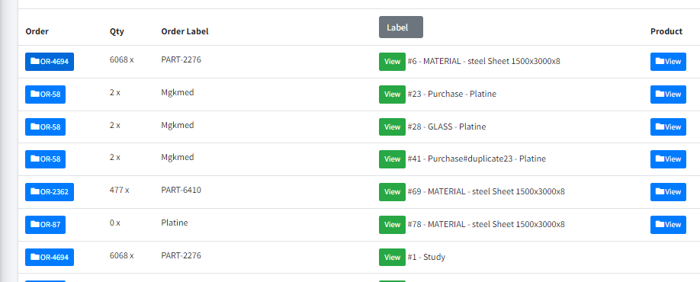

Not include generic task in date calculation #220
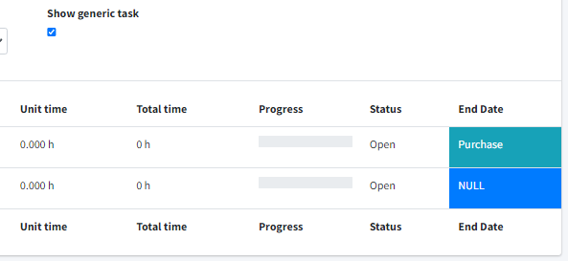

Change logo #231



Csv import #226
